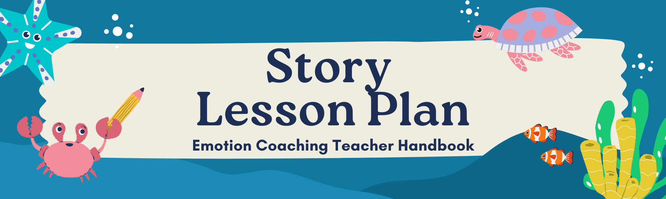

| af2a70309781a0dc75634e2a6cc4095e.png | **Read-Aloud**  As you read, pause to ask questions and engage students in discussions about Mr. Fish’s feelings at different moments and how his emotions and actions change throughout the story. |
| --- | --- |
| bc2c2021-edf5-4464-9879-afd7e9c19148.png | **Main Themes** Anger (its experience, expression , and regulation); empathy; decision-making; and problem-solving. |

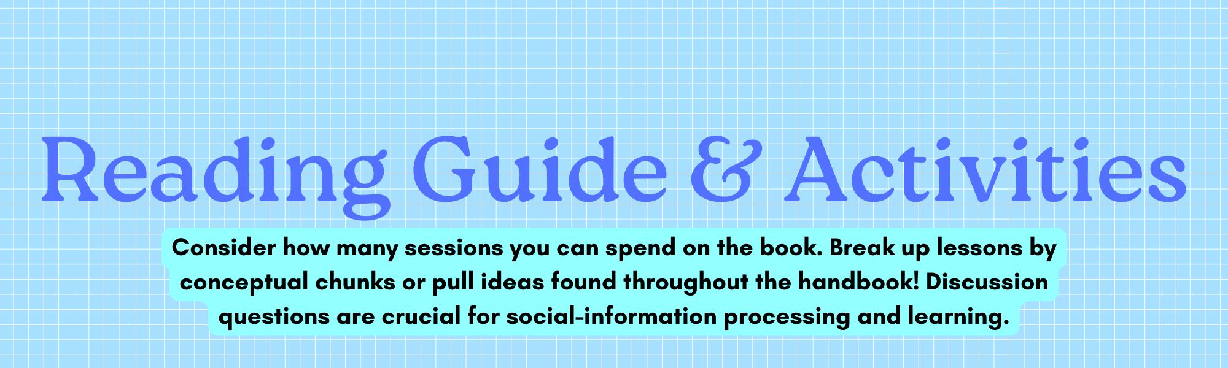

| fcecdaeab16d3916402a1b888e8e9c55.png | **Pages 1-3**  **Setting the Scene** |
| --- | --- |

**This story starts with an unfortunate event for Mr. Fish!**

| 5764b543-40cf-45cd-a6d4-ebd202033841.png | **Discussion Questions:**   1. “What happened to Mr. Fish?”    1. Ask directly if not already mentioned; emphasize if mentioned: What is the significance of the glue stick being missing? 2. “What is Mr. Fish feeling?” 3. “What do you think you might feel if you broke something by accident or made a mistake like Mr. Fish?”    1. This allows children to connect with Mr. Fish’s feelings and recognize when they have experienced similar emotions. |
| --- | --- |
| 4cbb3c8f4833d6ecf28d154552043e45.png | **Page 4**  **Exploring Assumptions and Perspectives** |

**It is important to note that Mr. Fish attempted to reach out to his friends for help, however it is not clear in the story whether he communicated in a positive way. It is possible that Mr. Fish felt like it was a very important situation and may have exaggerated the situation and its urgency.**

| 5764b543-40cf-45cd-a6d4-ebd202033841.png | **Discussion Questions:**   1. What did Mr. Fish decide to do after his souvenir broke and he couldn’t find the glue stick? 2. Do you think that Mr. Fish asked for help in a positive way? Was he communicating his needs clearly, complaining, or venting? Why do you think so? |
| --- | --- |

**Exploring Assumptions & Perspectives**

**Sometimes people can misunderstand situations based on their background feelings, assumptions or expectations. This is a chance to discuss how our emotions can influence how we interpret other people’s actions.**

| 5764b543-40cf-45cd-a6d4-ebd202033841.png | **Discussion Questions:**   1. What was Mr. Fish expecting from his friends? What did he want his friends to do? 2. Do you think Mr. Fish’s friends were intentionally ignoring him? How do you know?    * 1. How else might Mr. Fish interpret his friends’ responses besides that they don't care? For example, what if they just didn’t understand *why* it was a big deal? |
| --- | --- |

**The idea is that it is important to notice social cues to better understand others’ intentions--before acting based on our assumptions!**

| b3677760-d536-4b5d-ac4d-a28587a8f2b4.png | **Real Life Connection**  Ask the kids to think about a time when they tried to communicate something important to a friend or family member, and it didn’t work.   1. If you were a friend of Mr. Fish and he started to share how angry he was, how might you respond?    1. Would you know what to say or how to react? 2. What can you do if you think someone isn’t paying attention to you?    1. How do you know when they are ready to focus on you?    2. Would you try to talk to them again? |
| --- | --- |

| 62b909fc0184d1bb6d879cdbcfcd9fd2.png | **Pages 5-11**  **Feeling Out of Control!** |
| --- | --- |

**Mr. Fish is having trouble managing his emotions and body. When we’re really mad, our minds get scrambled. It’s like when the weather is stormy—everything’s cloudy and hard to see. When we feel calm, we can think more clearly, just like when the weather clears up after a storm.**

| 5764b543-40cf-45cd-a6d4-ebd202033841.png | **Discussion Questions:**   1. What do you think feeling *‘out of control’* means? 2. What does he say or do that shows us that he is feeling out of control? 3. Does Mr. Fish know that he is out of control? 4. What should Mr. Fish do if he is confused about what he feels? |
| --- | --- |

| 551a02d2-34fd-4a48-ac1e-5853d2c7e482.png  **Feelings Thermometer Activity**  Purpose: To practice empathy and better communication when someone feels misunderstood.  [**Feelings Thermometer Activity & Scenarios**](https://vkrp.virginia.edu/content/pdfs/06b.%20Activity_Feelings%20Thermometer.pdf)  [Behavior Management Feelings Thermometer](https://www.teacherspayteachers.com/Product/Behavior-Management-Feelings-Thermometer-2706096)  Objectives:   * Recognize emotions in self and others * Express a range of emotions   Materials:  ☐ Social scenarios (included; or create your own)  ☐ Feelings Thermometer worksheets for each student (or have them create their own)  ☐ Consider incorporating the [Glitter Jar](https://heartmindkids.com/how-to-make-a-glitter-jar-for-mindfulness/) |
| --- |
|

| 03f2837c0ebaf0d5bc2a157ffafd1e75.png | **Pages 12-15**  **Peer Support & Inner Balance** |
| --- | --- |

**Mr. Fish’s friends attempt to make him feel better by normalizing anger feelings. We all get mad sometimes! Yes, it might take some time and effort to calm down, but there are many things we can do to feel better and solve our problems.**

| 5764b543-40cf-45cd-a6d4-ebd202033841.png | **Discussion Questions:**   1. Why are friends responding to Mr. Fish now?    1. His friends see that he is out of control and he has caught their attention.    2. In regards to how this situation is different from before, his friends could be more available to talk and pay attention to Mr. Fish. 2. Is this a good way to get your peers’ attention? 3. What were the friends’ intentions? 4. Do you think that the peers will succeed in making Mr. Fish feel better? Why or why not? |
| --- | --- |
| 2d842e0c-ef7b-440f-b610-b8f6aa2404be.png | **What is Inner Balance?**  Has anger ever taken over and you no longer feel like who you are? What does it mean to return to feeling 'you'? |

| f3bddaddbff82404999089ec644d68a8.png | **Pages 16 & 17**  **Feeling Misunderstood** |
| --- | --- |

**Sometimes our anger is so big that it is hard to listen to what others have to say. Discuss how his growing feelings of anger interfered with Mr. Fish’s ability to consider his friends’ suggestions.**

| 551a02d2-34fd-4a48-ac1e-5853d2c7e482.png | **Re-Introduce the Feelings Thermometer!**   1. What is Mr. Fish feeling inside? 2. Where might his emotions be on the thermometer?   This is a good place to build on the idea of **feeling out of control.** Although time has passed since the initial moment that made Mr. Fish upset (i.e., his broken souvenir and missing glue stick), his anger has continued to grow. |
| --- | --- |

| 5764b543-40cf-45cd-a6d4-ebd202033841.png | **Discussion Questions:**   1. How did Mr. Fish receive his friends’ words? 2. How did you want people to help you when you were upset?    1. Sometimes, we just need **space** before we are ready to talk about what happened and our feelings–and that’s okay! 3. After responding to his friend, Mr. Fish chose to move away. Do you think he made the right choice? Why or why not? |
| --- | --- |

| **Feeling Misunderstood Role Play Activity**  Purpose: To practice empathy and better communication when someone feels misunderstood. | |
| --- | --- |
| 785ea1a4-4408-4f73-af6a-453e7e61c482.png | Instructions:   1. Pair up students. 2. One student will act as Mr. Fish (feeling upset) and the other will be a friend who wants to help. 3. The student playing Mr. Fish will express feeling misunderstood or frustrated (using their words or acting out) while the friend listens and tries to respond in a helpful and empathetic way, like asking “I’m sorry you’re feeling that way.” or “How can I help you?” 4. After a couple of minutes, have the students switch roles so both get a chance to practice listening and responding with empathy. 5. After the role-play, ask:    1. *What was it like to listen to your friend and try to help them feel better?*    2. *How did it feel to have your feelings heard?* |

**Remind children that it’s okay to feel upset or misunderstood, but it’s important to communicate and listen to others' feelings. Asking how someone feels and listening closely can be helpful before offering solutions.**

| 2df46dc9d5bd2acb5646d94c1e2e829f.png | **Pages 18 & 19**  **The Power of Taking a Pause & Calming Down** |
| --- | --- |

**Taking a Pause or Break**

**Taking a moment to calm down allows the brain to think more clearly and helps us approach the situation with more patience and understanding. This pause can help prevent mistakes made in the heat of the moment and open the door to better problem-solving.**

| 5764b543-40cf-45cd-a6d4-ebd202033841.png | **Discussion Question**   1. What do you think would have happened if Mr. Fish took a little pause before acting on his feelings? |
| --- | --- |

| **Calming Strategies Activity**  To help your kids develop their own strategies for dealing with frustration, give them an opportunity to share what works for them when they’re upset.  *What’s something you do when you need a moment to calm down, so you can think clearly?* | |
| --- | --- |
| ☐ Write their strategies on the board/piece of paper.  ☐ Practice each of the strategies for 2 minutes each.  ☐ Ask kids what they thought of the strategies.  ☐ Encourage them to remember their favorite strategy the net time they’re upset! | |

**Calming Down**

| 5764b543-40cf-45cd-a6d4-ebd202033841.png | **Discussion Questions:**   1. What calming strategies does Mrs. Squid suggest that Mr. Fish try? 2. What changed for Mr. Fish? What might he be thinking/feeling now? |
| --- | --- |

**Now that Mr. Fish's body has calmed down, Mr. Fish can think more clearly about what happened that led to his angry feelings as well as how to solve his problem!**

| 261b6c1660d53996dd981ea4775eb9fe.png | **Pages 20-23**  **Feeling Multiple Emotions at Once** |
| --- | --- |
| 5764b543-40cf-45cd-a6d4-ebd202033841.png | **Discussion Question:**   1. What do you think is making Mr. Fish feel mad and sad at the same time? 2. What do you think this feels like? |

| **Anger Iceberg Activity**  An Anger Iceberg lesson is a great way to teach students about managing their emotions and understanding the underlying causes of their anger.  [Anger Iceberg](https://www.centervention.com/anger-iceberg/)← Follow the steps on the website! | |
| --- | --- |

| 92fb84db7d9f7042a0564bcc4d21d07a.png | **Pages 24-27**  **Circling Back: Anger’s Early Warning** |
| --- | --- |

**Here, his friends “listened closely” even though at the beginning Mr. Fish believed that they were ignoring him intentionally.**

**Take a moment to recall this situation, which initially led to Mr. Fish’s increased anger, and build on the idea of misinterpretations of others’ actions and how things often are not what they seem.**

| 5764b543-40cf-45cd-a6d4-ebd202033841.png | **Discussion Question:**   1. How did Mr. Fish's interactions with his friends change? Why are they listening to him now? |
| --- | --- |

**Mr. Fish’s friends showed him that they care about him and want to help him feel better and problem-solve!**

| **Anger’s Early Warning Activity**  What were some of the early signs of Mr. Fish’s anger?  [Anger Warning Signs – The Key To Teaching Anger Management](https://confidentcounselors.com/anger-warning-signs-the-key-to-teaching-anger-management/)← Here is a website that include ideas for worksheets and activities that can help children reflect on warning signs that are relatable to their experiences. | |
| --- | --- |

| 0fb02f13e9f60f5bd176dd161f977f44.png | **Pages 28-29**  **Problem-Solving & Self-Compassion** |
| --- | --- |

**How Does Anger Get in the Way of Problem-Solving?**

**Once Mr. Fish started feeling angry, it was difficult for him to find what he needed in order to fix his souvenir. If we look closely, the glue stick that he needed was in one of the boxes that Mr. Fish had started to look in at the beginning.**

| **Look back at Page 1:**  Where does Mr. Fish look for his glue stick? | **Turn back to Page 20:**  Where does his peer find the missing glue stick? (He was so close to finding it--it was right under his nose!) |
| --- | --- |

**When we learn to regulate our anger, we are able to think of more solution options and keep trying until we reach our goals in positive ways.**

| **Vignette Activity: “What Would You Do?”**  Purpose: Use brief, relatable vignettes where children experience frustration or anger, just like Mr. Fish, and have to make decisions in those moments. This interactive activity can help them apply the concept of making good decisions when upset.  Examples are provided below but feel free to create scenarios that are relatable for your kids! |
| --- |

| Younger Children | Older Children |
| --- | --- |
| **Sharing Toys:** You were waiting for your turn to use a toy, but another child grabs it before you can. You feel angry. *Do you shout at them, or do you ask if you can take your turn next?* | **The Block Tower Falling Down:** Imagine you’ve been building a really tall block tower, and someone accidentally knocks it down. You worked so hard on it. *What might happen if you shout at your friend or push the blocks away because you’re mad?* |
| **Losing a Game:** You’re playing a game with your friend, but they keep winning, and it’s making you mad. *Do you keep playing and try to have fun, or do you stop the game because you’re upset?* | **Not Understanding a Homework Question:** You’re trying to solve a homework problem, and no matter how hard you try, you just don’t get it. You start to feel frustrated and mad. *What happens if you stay angry and don’t ask for help? What could happen if you take a deep breath and ask someone to explain it to you?* |

| Vignette Activity Wrap Up  Connect back to the story: When Mr. Fish was mad, he couldn’t think clearly, his anger continued to grow.   1. How did he feel when his friends tried to help, and why didn’t that work at first? 2. What do you think he could have done differently to calm down and think more clearly? |
| --- |

**What is Self-Compassion?**

**Self-compassion is about being kind to ourselves when we feel sad, frustrated, or upset—just like we would be kind to a friend who was feeling that way.**

| **Introduce the idea of being a good friend to yourself:** | * It is okay that I am angry. * I can accept my feelings without blaming anyone else. * Instead of being mean or hard on myself, I can say something kind, like 'It’s okay, I’m doing my best.'" * I am capable of problem-solving. * If I can’t figure it out on my own at first, I have friends or adults I can go to for help. |
| --- | --- |

| 5764b543-40cf-45cd-a6d4-ebd202033841.png | **Discussion Questions:**   1. What do you think Mr. Fish said to himself when things weren’t going well? Was he being kind to himself, or was he being hard on himself? 2. What do you think would have happened if Mr. Fish was kinder to himself? Would it have helped him feel better faster? |
| --- | --- |

| **Apply: I can be self-compassionate when I am angry by...** |
| --- |

| Taking deep breaths—to calm down and slow our emotions. | Saying something kind—like 'It’s okay to make mistakes' or 'I’m doing my best.' |
| --- | --- |
| Giving ourselves a break—sometimes it’s good to step away from a tough situation and rest for a little while. | Asking for help—it’s okay to reach out to a friend or family member when we’re feeling down. |

| 72df217ce711d0ad418f9e6165943e07.png | **Page 30**  **Putting it all together** |
| --- | --- |

| 5764b543-40cf-45cd-a6d4-ebd202033841.png | **Summary of General Questions:**   1. How did Pout-Pout Fish feel at the beginning of the story? 2. What made him feel frustrated and angry? 3. How did he act when he was upset? 4. Have you ever felt like Pout-Pout Fish? What happened? |
| --- | --- |

| 551a02d2-34fd-4a48-ac1e-5853d2c7e482.png | **Anger Growing Inside Activity**  Angry feelings can increase or decrease depending on the subsequent interactions. Go through important parts of the story and ask children to indicate (or write) where Mr. Fish’s feelings were on the Anger Thermometer. |
| --- | --- |

| **Moments of Anger Increasing**   * 1. Souvenir broke   2. Couldn’t find glue stick   3. Assuming friends were ignoring him   4. Getting tangled in the weeds   5. Feeling misunderstood by his friends | **Moments of Anger Decreasing**   * 1. Friend helped him take deep breaths and counting from one to ten   2. Felt heard by his friends   3. Talked about what happened and his feelings   4. Friends helped him find the glue stick   5. Glued the pieces of his souvenir back together |
| --- | --- |

| bc2c2021-edf5-4464-9879-afd7e9c19148.png | **Bonus:** What was Mr. Fish thinking at each of these moments? |
| --- | --- |

