Uploading Your CITI Report to Student Learning & Licensure:

Log onto your Student Learning & Licensure Account using the link: https://sll.watermarkinsights.com/
In the Course tab, locate the course and click on the course title
Select the CITI Report Submission Activity:
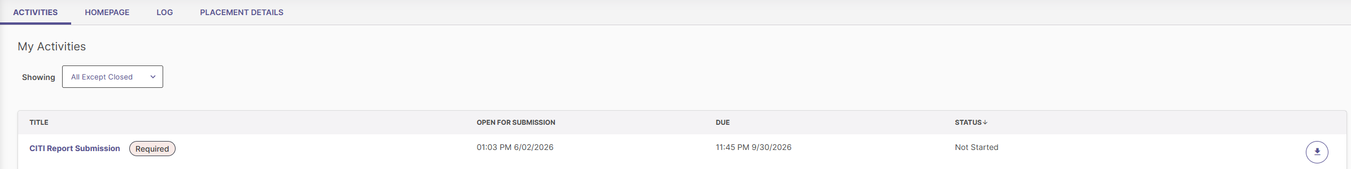
Click the “Select File” button
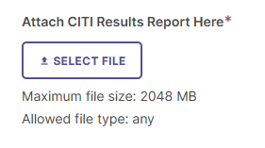
Click on the “Add File” button. Select the CITI Report document (you have a choice of your local computer, Google, Dropbox or in SLL (if already uploaded to the platform)
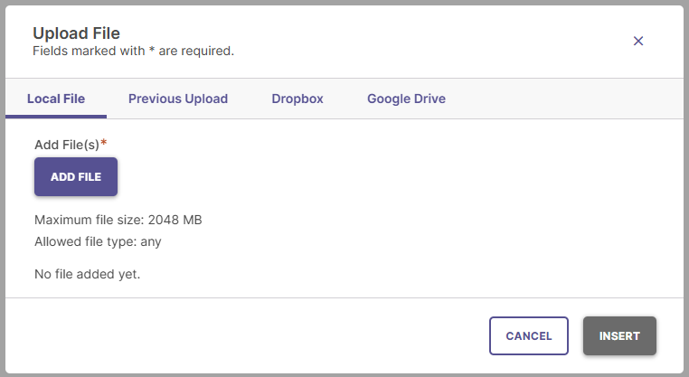
Click “Insert” to add the document.
Verify that the document is attached to the activity, click the “Submit” button on the top right corner of the screen. If you need to delete the document, you can do so by clicking on the trash can icon.
Once submitted you will be provided with a brief message notifying you of the submission. Additionally, the status on your Activities dashboard will change to “Awaiting Assessment”
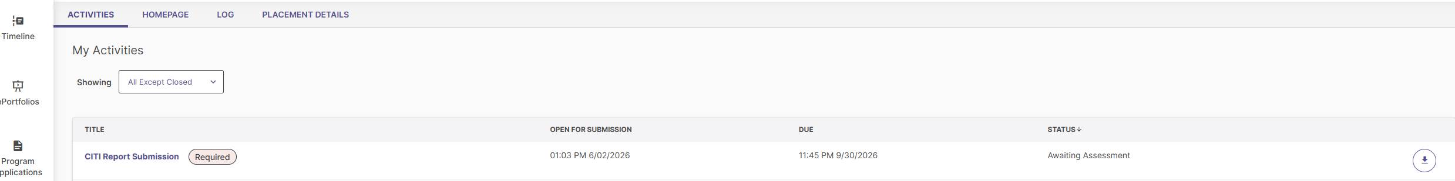

If you have any further questions, please contact the Assessment Office at: dnnorth@umd.edu

